Frequently Asked Questions about infant safe sleep
Complete the worksheet with the workshop facilitators.

Can we use a pacifier with our baby while she’s sleeping?

Is it safe to swaddle our baby?

My baby cries a lot and we get frustrated. How can we get him to stop crying?

The doctor said our baby has acid-reflux. Should we still follow the safe sleep guidelines?

Our baby is 8 months old and can roll over in his sleep. What should I do?

My grandma made a quilt for our baby. We don’t want to disrespect her, but we want our baby to be safe to sleep. What can we do?

Where can we get a crib?

Myth Busters
Complete the worksheet with the workshop facilitators.

MYTH | DEBWE/TRUTH
My baby is healthy and doesn’t need to sleep on his back.

Babies can choke on their spit-up if they sleep on their back.

I’m breastfeeding so my baby is safe sleeping with me.

Babies need blankets and soft things to keep them comfortable.

All my children went to sleep on their tummies, and they survived. So my grandkids don’t need to sleep on their backs.

Make it Safer
Complete the worksheet with your own answers.

Situation 1
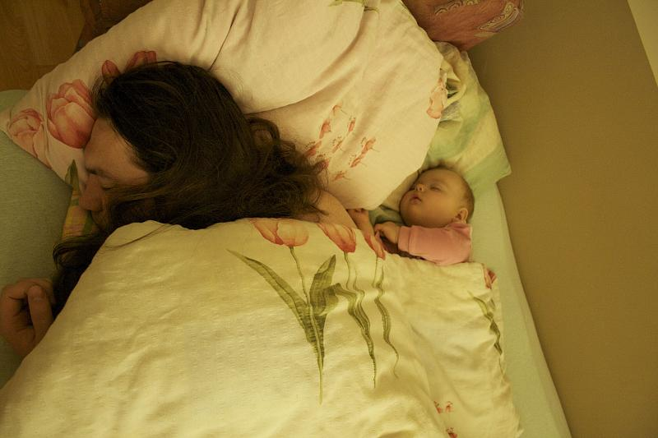

What’s unsafe about this situation? | How could you make it safer?

Situation 2
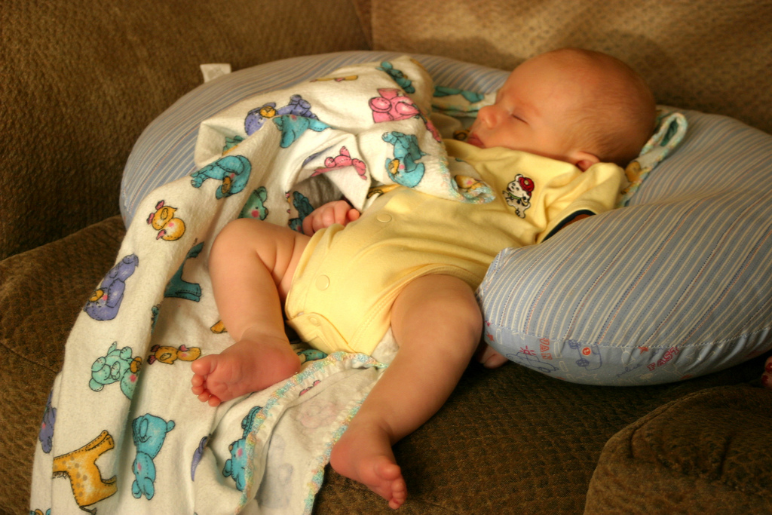

What’s unsafe about this situation? | How could you make it safer?

Situation 3
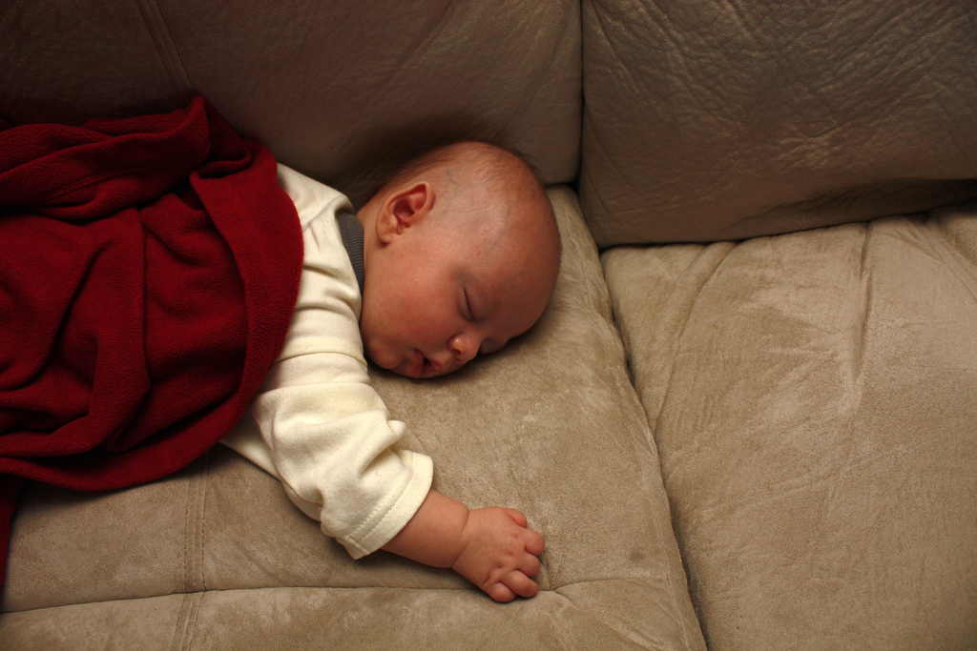

What’s unsafe about this situation? | How could you make it safer?

