Lesson 10 (Midaaswi): Tracing

Lesson Objective:
The child will further their abilities in shapes, letters, objects and scribbles to express their stories, experiences and ideas.

Medicine Wheel Wisdom:

We can include our “way of life”, like the 7 Grandfather teachings, when we are helping our children with skills that support early learning.

Use the checklist below to help introduce the lesson to the family. These items are actions that we hope to support in our work with the family.

Family Outcomes (PICCOLO):
- Encourages the child to handle toys and writing utensils
- Supports the child in doing things independently
- Verbally encourages the child when the write or draw
- Attends to the child’s skills and emotions while providing support

Child Behavior Outcomes (LOLLIPOP):
- Can use crayons and other writing utensils
- Develops a familiarity with writing tools and using them
- Practices writing beginning shapes, symbols and letters
- Learns the Medicine Wheel colors and directions

Home Visitor Lesson Overview:

Materials Needed:
- Pencil and Crayons
- Medicine Wheel Coloring Sheets
- “Show Me My Name” and “Capital Formation Chart”
- Sentence Writing Strips
- Tip-Sheet: “How to Hold a Pencil/Crayon”

Lesson:

- According to the child’s ability, choose one of the versions to complete with them.

- When the version is chosen, help the child set up their writing station and hold their pencil.
Version 1:
- The child can start with whatever shape page they wish.
- After they have finished one or two, transition to the parent helping with the activity.

Version 2:
- The child can pick which lines they trace over first.
- After they have finished one or two, transition to the parent helping with the activity.

Version 3:
- The child can choose what lines they want to trace first.
- After a few, transition to the parent helping and reading the activity.

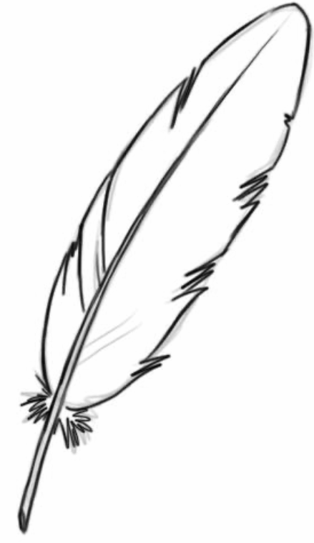
Remind them to always encourage, never scold, their child as they participate in this important first step to early writing.

Lesson Wrap-Up:
- Tip-Sheet: “How to Hold a Pencil/crayon”
- “Show Me My Name” and “Capital Formation Chart”
- Sentence Writing Strips
- Explain Lesson 10 Activity

