Lesson 4 (Niiwin): Using a Pencil/Crayon

Lesson Objective:
The child will learn to hold a writing utensil and be able to write their name and draw shapes and scribbles to represent objects, stories, experiences and ideas.

Medicine Wheel Wisdom:
Every new skill has a learning process. A beginning and an end just like the medicine wheel. Exploring, drawing and coloring are important beginning steps to writing. Developing skills to hold a pencil/crayon will help them as they learn to write. When we encourage what they are doing, it helps them build confidence for the next skills children need to learn.

Use the checklist below to help introduce the lesson to the family. These items are actions that we hope to support in our work with the family.

Family Outcomes (PICCOLO):
- Understands the differences in learning progression
- Encourages the child to hold writing utensils
- Verbally supports and acknowledges their drawings
- Attends to their skills and emotions

Child Behavior Outcomes (LOLLIPOP):
- Uses crayons and other writing utensils
- Develops a familiarity with writing tools
- Practices writing beginning shapes, letters and symbols
- Learns the Medicine Wheel Colors and directions

Home Visitor Lesson Overview

Materials Needed:
- Crayons & Markers
- “Show Me My Name” & “Capital Formation Chart”
- Sentence Writing Strips
- Tip-Sheet: “How to Hold a Pencil/Crayon”

Lesson:

- Today’s activity is to allow the child to explore drawing and coloring. Coloring, including scribbling, is an important first step to early writing skills.

- Ask the child to choose a coloring book from their collection, or use the coloring sheets provided in your kit. Let the child use as many or as few crayons as they want.
- With the parent, show how to set up the coloring station by having the child comfortably positioned with their paper and crayons.

- Model how to properly hold a crayon or pencil. Reference the tip sheet if needed.
- Place the writing utensil in the middle of the sheet and allow the child to pick what hand they use.
  - Praise any effort.

- Allow the child to color and draw on the medicine wheel and the other coloring pages.

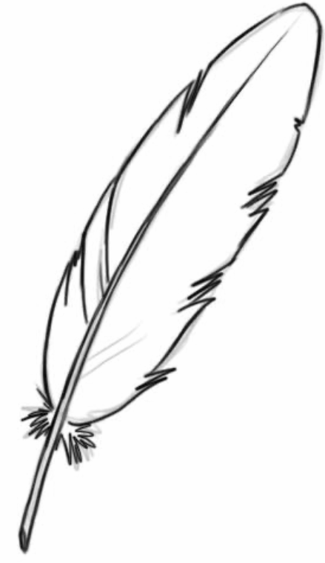
Children of all skill levels can tell stories through drawing! Encourage their expressions and choices.

- Transition the parents to draw/coloring with their child. Provide guidance, encouragement, and remind the parents to always encourage their child as they participate in this important first step to early writing.

Lesson Wrap-Up
- Tip-Sheet: “How to hold a Pencil/Crayon”
- Crayons & Markers
- “Show Me My Name” & “Capital Formation Chart” Sheets
- Sentence Writing Strips
- Explain Lesson 4 Activity

