Lesson 6 (Ngodwaaswi): Sorting Beads

Lesson Objective:
The child is able to use and begin to understand number concepts and operations.

Medicine Wheel Wisdom:
The medicine wheel helps us to understand that there is a time, a place, and a process for everything. Number symbols help us understand our world, including things such as time and place. Working with numbers is also a process. When we help children learn to count and sort, it helps them understand how to use numbers and number symbols.

Use the checklist below to help introduce the lesson to the family. These items are actions that we hope to support in our work with the family.

Family Outcomes (PICCOLO):
- Helps the child say and identify names and number symbols
- Caregiver is aware that counting and sorting can be included in everyday life

Child Behavior Outcomes (LOLLIPOP):
- Can say number names and count objects verbally
- Associates verbal numbers with the correct number symbol
- Practices writing numerals
- Is able to sort and match like symbols and colors

Home Visitor Lesson Overview:

Materials Needed:
- Medicine Wheel Kit
- Tip-Sheet: “Finding the Math” & “Math During Everyday Home Routines”
- Number Symbols Sheet
- Number Tracing Sheet
- Beads/String

Lesson:

- Sit beside the child and reintroduce numbers 1-10 using the number symbols sheet.

- Point out the 4 colors on the Medicine Wheel and allow the child to pick out a favorite color.

- Have the child sort out the colors from the pile and group them on the medicine wheel.

- Help the child count the amount in each pile and identify the number symbols on the chart.
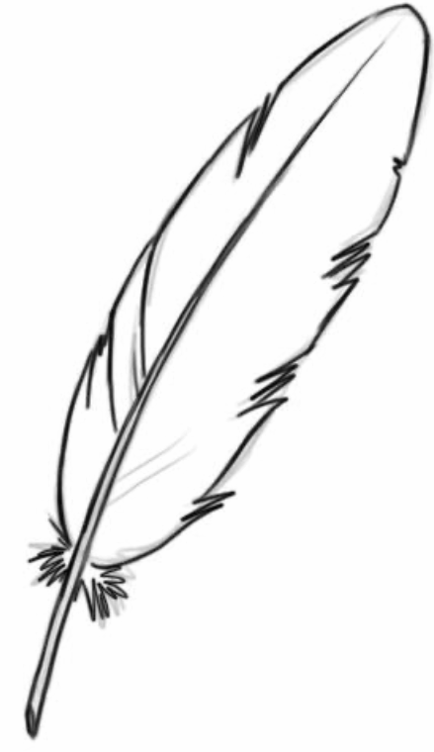
Support the child with identifying number symbols and names if necessary!

- After sorting a few colors, transition to the family member working with the child on sorting the beads by color on the Medicine Wheel.

- When all four colors have been sorted, compare amounts in each color to the symbol on the number sheet.

Lesson Wrap-Up:
- Number Symbols Sheet
- Number Tracing Sheet
- Tip-Sheet: “Math During Everyday Home Routines”
- Explain Lesson 6 Activity

