Gikinawaabi
Learn by Observing
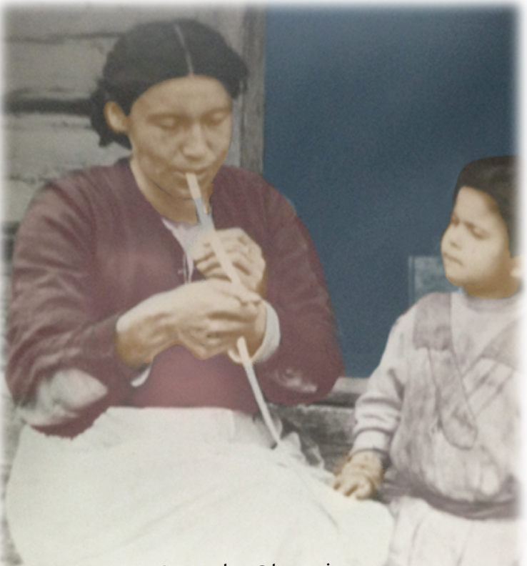

A Home Visiting Early Learning Supplementary Curriculum
For families of children ages 3-5 years old

About the Cover: This picture by Artist Deb Pine features her grandmother Mamie Pine teaching her daughter Elizabeth (Lizzy) Pine how to make Ash baskets.

AUTHORS

Jessica Barnes-Najor, University Outreach & Engagement, Michigan State University
Kailey Cline, Tribal Early Childhood Specialist, Nottawaseppi Huron Band of the Potawatomi
Elizabeth Kushman, Maternal, Infant & Early Childhood Division, Inter-Tribal Council of Michigan
Amanda Leonard, Maternal, Infant & Early Childhood Division, Inter-Tribal Council of Michigan
Elizabeth Leffler, Community Outreach Supervisor, Pokagon Band of the Potawatomi
Raeanne Madison, Maternal, Infant & Early Childhood Division, Inter-Tribal Council of Michigan
Lisa Martin, Maternal, Infant & Early Childhood Division, Inter-Tribal Council of Michigan
Susan Morningstar, Head Start/Early Head Start Program, Inter-Tribal Council of Michigan
Courtney Pasek, OPEN MSU, Maternal, Infant & Early Childhood Division, Inter-Tribal Council of Michigan
Michelle Leask (Schulte), Maternal, Infant & Early Childhood Division, Inter-Tribal Council of Michigan
Darlene VanOveren, Home Visitor, Inter-Tribal Council of Michigan

Contributing Professionals & Organizations
Joann Knapp-Philo, Office of Head Start, National Center on Cultural & Linguistic Responsiveness
Deborah Shuey, Office of Head Start, National Center on Cultural & Linguistic Responsiveness

Acknowledgements
Meg Noodin, University of Wisconsin-Madison
Ann Belleau Head Start/Early Head Start Program, Inter-Tribal Council of Michigan

The Gikinawaabi Supplementary Curriculum was produced by the Inter-Tribal Council of Michigan under grant #90TH0025-03-00, funded by the Affordable Care Act of 2010, awarded by the Office of Child Care, Administration for Children and Families, U.S. Dept of Health and Human Services (HHS). The opinions, findings, conclusions, or recommendations expressed in this document are those of the contributors and do not necessarily represent the official position or policies of the HHS.
Other materials, handouts, graphics and content are used with permission, or are in the public domain.

Table of Contents

Introduction:
- Authors & Contributors….………………………………………2
- Table of Contents/Home Visitor Content/Reference.………..3
- About Gikinawaabi ……………………………………………...4
- Teaching the Medicine Wheel………………………………….5
- Early Learning Journey……..…………………………………...6
- Overarching Principles……...………………………………......7
- Home Visitor Checklist Tips…..………………………………...8

Home Visit Content:
- Lesson 1: Appreciating Books
- Lesson 2: Medicine Wheel Book
- Lesson 3: Let’s Count
- Lesson 4: Using a Pencil/Crayon
- Lesson 5: Medicine Wheel Kit
- Lesson 6: Counting with Beads
- Lesson 7: Alphabet Books
- Lesson 8: Drawing the Medicine Wheel
- Lesson 9: Animal Graph Kit
- Lesson 10: Letter Tracing
- Lesson 11: Storytelling
- Lesson 12: Colors in the Home
- Lesson13: “Stop & Go!” and “I Spy…”

Tip Sheets:
- Alphabet Knowledge
- Book Appreciation
- How to Hold a Pencil/Crayon
- How to Read to a Child
- Using the Medicine Wheel to Communicate
- Print Concepts
- Ways to Use the Medicine Wheel Kit

About Gikinawaabi

Pronounced Gi-Kin-Awa-Beh, it means to learn by observing. Traditionally, our children have always been encouraged to learn about the world through respectful observation.

We have a teaching about the “Oshki Anishinaabeg” (meaning "new" people) that provides a strong foundation for understanding early learning in this context. Every generation has the opportunity, and responsibility, to heal from trauma and create a new way of life for our children, using our traditions. The right time to make a difference is now, because the actions of this generation will positively impact the next seven generations to come.

Gikinawaabi was designed to ground early learning activities in our traditional lifeways. The skills needed for early reading, math and language are all inherent in our culture. In today’s world, we recognize the importance that children’s experience in school has on the rest of their life. We also recognize connecting children to their lifeways and language also helps them throughout their lives. The content of Gikinawaabi targets specific school readiness skills by utilizing the innate richness of our Anishinaabe way of life.

Respectful observation is central to the approach by:

- Respectful observation of the child by the home visitor, to tailor activities to his or her emerging skills, interests and needs.

- Respectful observation of the parent by the home visitor, to provide encouragement and build on strengths.

- Respectful observation of the home visitor by the parent, to model supportive child interaction.

- Respectful observation of the child by the parent, to follow their child’s cues and encourage practice of new skills.

- Respectful observation of the world by the child who is learning about the interconnectedness of all things, and to gain an understanding of life as a journey of learning.

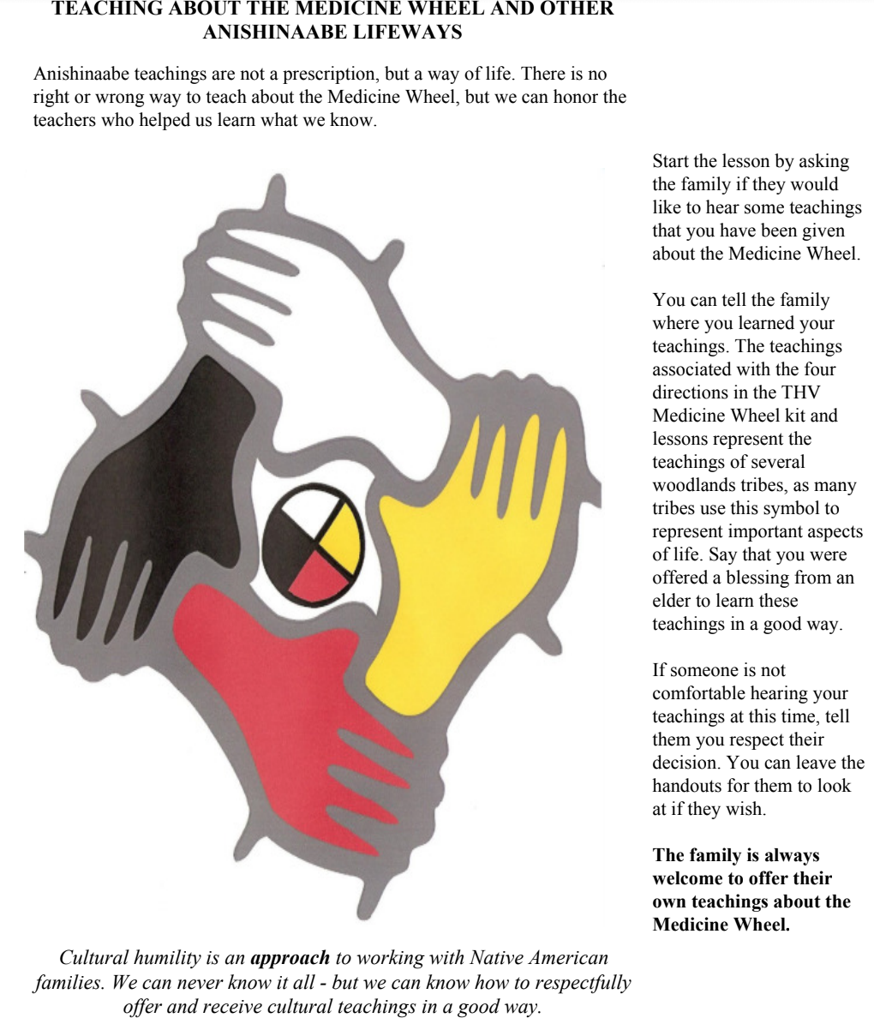

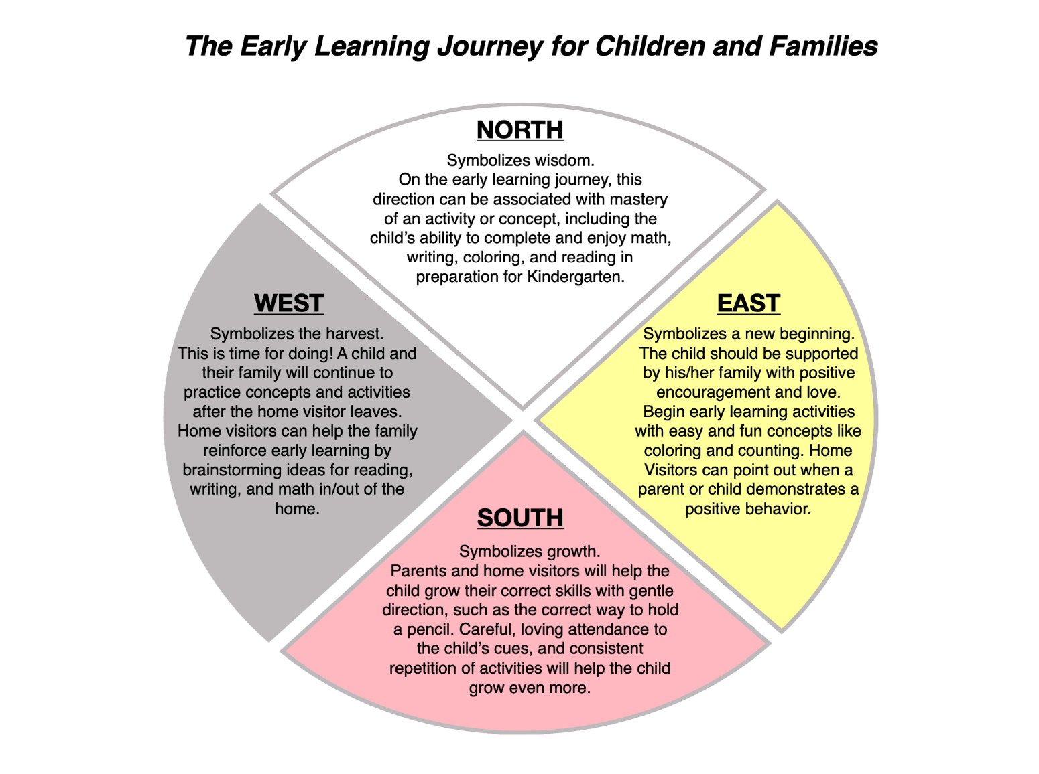
Overarching Principles for Working with Children and Families on Early Learning Concepts

- Attending to a child’s cues is always important. Build choice into the activity so the child can choose according to their interests. This helps them gain a sense of independence.

- Children progress through developmental milestones at their own rate!

- We are helping parents to understand that learning before school can affect their health and their life significantly later on in kindergarten and even later for them in life.

- Always start an activity with something EASY to encourage and support confidence and interest in the activity.

- Reinforce repeating activities will help the child to learn. Brainstorm with parents on how to do activities performed in the home visit on a regular basis.

- Always provide positive guidance and feedback! Explicitly point out when a parent or child demonstrates a positive behavior.

- Some of elements of other lessons may be applicable to the lesson you are doing on a given day. For instance, don’t be afraid to remind the child while they are coloring the proper way to hold a crayon or pencil.

Home Visitor Checklist Tips

- Remind the family member that each child learns differently and at their own pace.

- Talk with the family member. Make them feel comfortable and relaxed! You are in their home!

- Discuss any upcoming events that they may have or any community events.

- Give any materials and have parents sign a receipt for documentation purposes.

- Ask if there have been any medical changes (i.e. heath insurance, has anyone been to the hospital, follow-up if any referrals were made).

- Ask if there were any milestone developments with the child (i.e. new tooth, rolled over, literacy improvements etc.).

- Check on any goals in progress that was discussed on the last visit.

- Check any things due for family spirit (i.e. 1 year old assessment, PICCOLO, LOLLIPOP, EPDS, ASQ, etc.)

- Recent well child visits/upcoming well child visits information.

- Update changes to address, phone number, family structure (new boyfriend, grandma moved in, etc.).

- Length, weight, head circumference (for child, ask updated weight for pregnant mothers) if applicable.

