Gikinawaabi
Learn by Observing
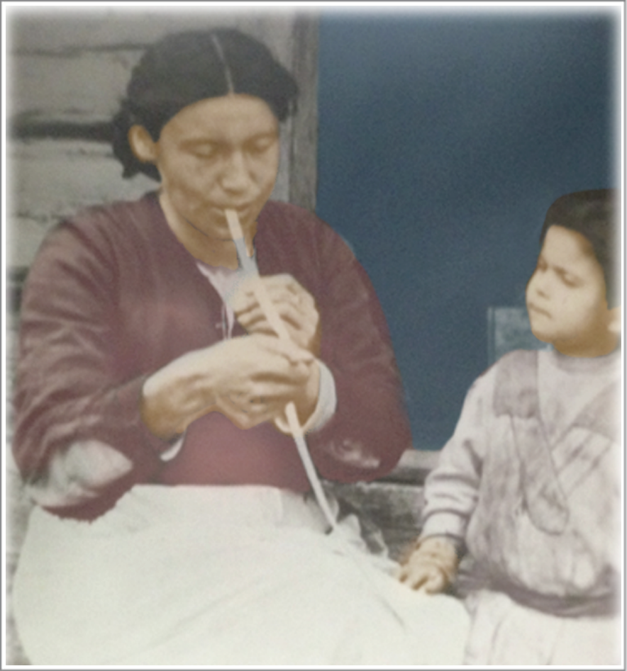

Parent & Child Activity Folder

