TIP SHEET:
Print Concepts

Learning about letters, numbers and symbols is an important part of a child’s learning and growing journey. Through letters and writing they start to create their own identity in their handwriting. It also is a creative outlet that allows them to explore letters, number and symbols as they continue learning.

- Use items that you have in your home such as food boxes/labels, newspapers, books, menus, maps etc. to do activities with your child.

- Engage children in making their own signs or labels using letter-like symbols, letters and their own writing.

- Track print when reading to a child from books or other resources. Point to specific words and demonstrate left-to-right reading motion.

- To help children recognize specific words, stop every now and then and point to the word and ask them to say it.

- Engage children in writing or exploring many different kinds of print for different purposes such as signs, lists, letters or directions.

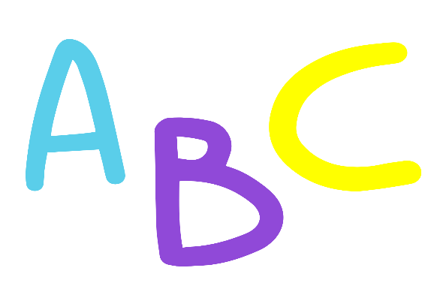
- Provide children lots of opportunities to write! For example, while you make a list, allow the child to make one of their own!

