The Medicine Wheel:
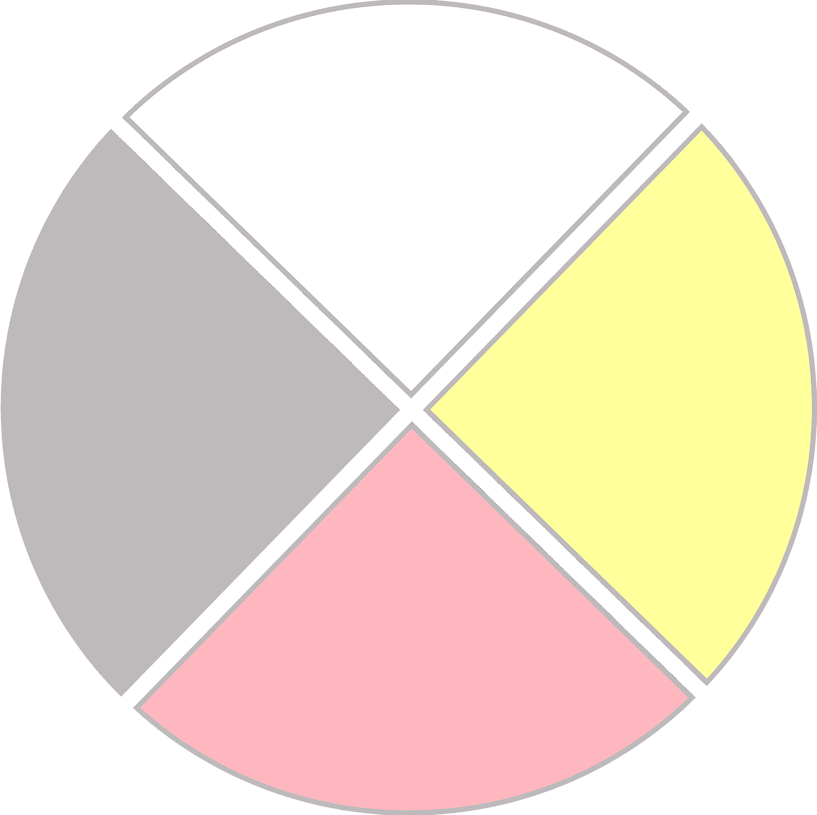
Native Teachings are about a Way of Life

The Medicine Wheel represents the four sacred directions of life and the journey that every person must take. Every tribal nation may have a different way of understanding the teachings, however, the following teachings are common to many Anishinaabe communities (Ojibwe, Bodewadomi, and Odawa).
- The East (Waabinong): the place of birth, babies, and spring. Waabinong teaches us to have hope for the future, to have courage, and to keep our selves pure – like newborn spirits. Waabinong is the place of leadership.
- The South (Zhowaanong): the place of childhood, summer, and self-control. It is important to learn what our gifts are and to keep our bodies pure and healthy. Children will learn to express themselves and be respectful to themselves and others in this phase of life. Music and art are gifted to us from Zhowaanong.
- The West (Epongishimag): the place of adulthood, knowledge, and autumn. Epongishimag teaches us to reflect on our life and begin to pass our teachings onto the next generation. It is when we begin to understand life’s meaning, and allows us to use our gifts to make the world a better place. It is a time for praying, fasting, and doing ceremonies.
- The North (Kewadinong): the place of elders, wisdom, and winter. Kewadinong teaches us to let go of anger, hate, and fear. It is the place of truth, and a time when elders will see their visions and dreams come true.

*Adapted from Tribal Community Prevention
*These teachings were adapted from the Tribal Community Prevention program by the Maternal and Child Health staff at the Inter-Tribal Council of Michigan

